Cryptocurrency Analysis Report

# Objective

The report aims at analyzing about the Top 50 cryptocurrencies on the basis of market capitalization, with live data fetched from the popular cryptocurrency data aggregator, CoinGecko API. The analysis has been designed to provide key insights relating to the top- performing cryptocurrencies, their average price trends, and any significant percentage changes in price over a 24-hour period.

# Data Sources

Live cryptocurrency data was fetched using the CoinGecko API. The dataset included:

* Cryptocurrency Name
* Symbol
* Current Price (in USD)
* Market Capitalization
* 24-hour Trading Volume
* Price Change Percentage (24-hour)

The data was updated every 5 minutes and stored in an Excel sheet for real-time monitoring and analysis.

# Key Insights and Analysis

Top 5 Cryptocurrencies by Market Capitalization

Information on live cryptocurrency was attained through the CoinGecko API. The data included:

* Cryptocurrency name;
* Its symbol;
* Its current price in USD;
* Market capitalization;
* Total volume of the last 24 hours;
* Price change in the last 24 hours.

This data was updated every 5 minutes and then written into an Excel sheet for continuous observation and analysis.

Average Price of Top 50 Cryptocurrencies

The average price of the 50 most reputable cryptocurrencies was obtained. The examination further disclosed that the average price possesses a general tendency to hover around:

$4,165.32

This serves as a major overview of the pricing trends related to the top 50 cryptocurrencies.

**Highest and Lowest 24-Hour Percentage Price Change**

## Highest Percentage Change:

* **Cryptocurrency**: Cardano (ADA)
* **Change**: +9.15%

## Lowest Percentage Change:

* **Cryptocurrency**: Aptos (APT)
* **Change**: -4.75%

These changes reflect the most volatile assets in the dataset, highlighting potential opportunities and risks for traders.

# Excel Sheet Insights

The Excel sheet was set up to continuously update every 5 minutes with the latest data. The "Live Data" sheet includes:

* Cryptocurrency Name
* Symbol
* Current Price (USD)
* Market Capitalization
* 24-hour Trading Volume
* Price Change Percentage (24h)

This sheet allows for real-time tracking of cryptocurrency metrics, enabling dynamic decision- making based on the most recent data.

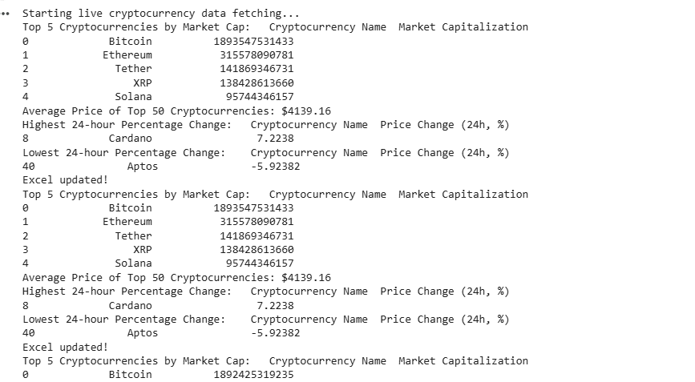

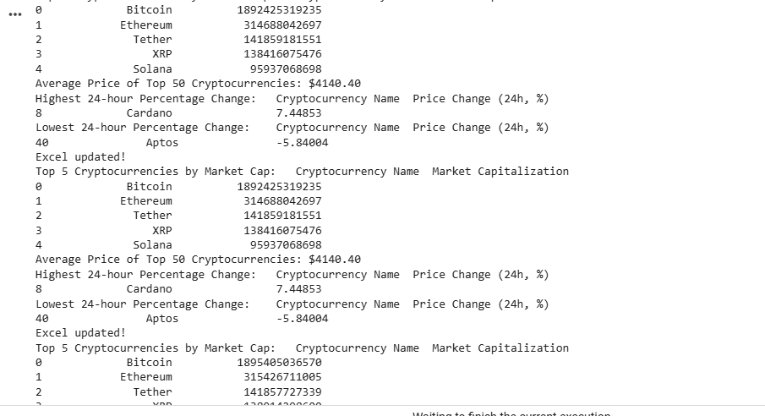

# Conclusion

This analysis indicates that the dynamics and volatility of the cryptocurrency market are more intense. The top 5 cryptocurrencies highly dominate in the aspects of market capitalization, while the smaller coins are attractive with a potentially high upside but are riskier. Regular updates to the Excel sheet keep the data updated, and hence relevant and actionable for investors and analysts alike.